$V_{SP}$ calculation:
$$\frac{{K_{n}}^{'}}{2}\frac{W_{n}}{L_{n}}{\left(V_{GS}-V_{tn}\right)}^{2}=\frac{{K_{p}}^{'}}{2}\frac{W_{p}}{L_{p}}{\left(V_{SG}-\left|V_{tp}\right|\right)}^{2}$$
$${K_{n}}^{'}{\left(V_{SP}-V_{tn}\right)}^{2}={K_{p}}^{'}\frac{W_{p}*L_{n}}{L_{p}*W_{n}}{\left(V_{DD}-V_{SP}-\left|V_{tp}\right|\right)}^{2}$$
$$\left(V_{SP}-V_{tn}\right)=\sqrt{\frac{{{K_{p}}^{'}*W}_{p}*L_{n}}{{K_{n}}^{'}*L_{p}*W_{n}}}*(V_{DD}-V_{SP}-\left|V_{tp}\right|)$$
$$V_{SP}+\sqrt{\frac{{{K_{p}}^{'}*W}_{p}*L_{n}}{{K_{n}}^{'}*L_{p}*W_{n}}}*V_{SP}=V_{tn}+\sqrt{\frac{{{K_{p}}^{'}*W}_{p}*L_{n}}{{K_{n}}^{'}*L_{p}*W_{n}}}*(V_{DD}-\left|V_{tp}\right|)$$
$$V_{SP}=\frac{V_{tn}+\sqrt{\frac{{{K_{p}}^{'}*W}_{p}*L_{n}}{{K_{n}}^{'}*L_{p}*W_{n}}}\left(V_{DD}-\left|V_{tp}\right|\right)}{1+\sqrt{\frac{{{K_{p}}^{'}*W}_{p}*L_{n}}{{K_{n}}^{'}*L_{p}*W_{n}}}}=\frac{0.68+\sqrt{\frac{38*{10}^{-6}*30*2}{118.4*{10}^{-6}*2*25}}\left(5-0.85\right)}{1+\sqrt{\frac{38*{10}^{-6}*30*2}{118.4*{10}^{-6}*2*25}}}$$
$$=2.008807902V$$
$V_{SP}$ simulation: 2.06292V
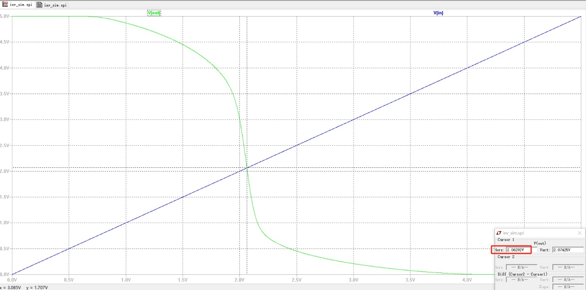

Noise margin:
High noise margin ${NM}_{H}=V_{OH}-V_{IH}=5V-2.21718V=2.78282V$
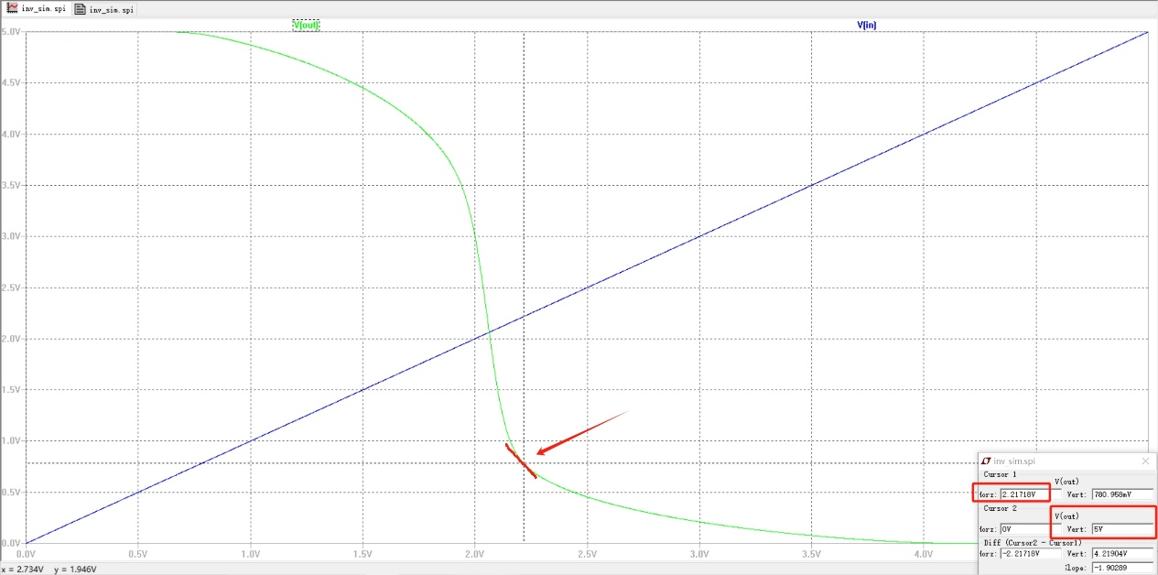
Low noise margin ${NM}_{L}=V_{IL}-V_{OL}=1.80883V-2.09682nV≈1.80883V$
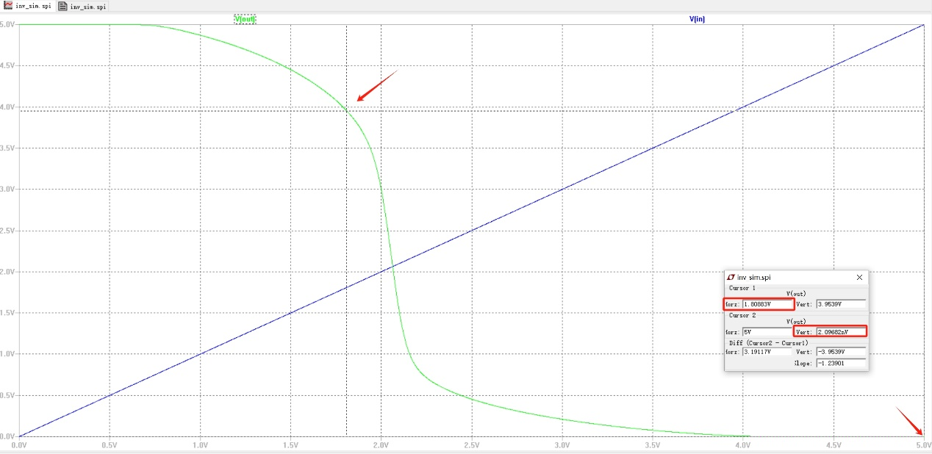

Current at $V_{SP}$: I = 823.759µA
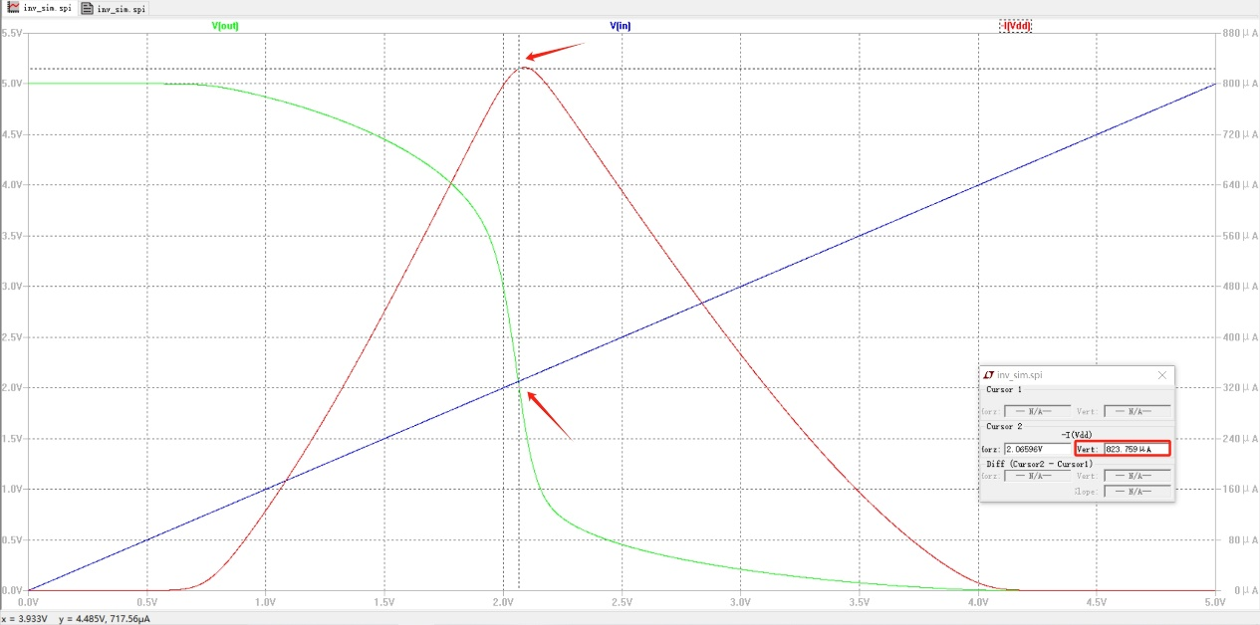
Current at $V_{SP}$ Calculation:
$$I_{DS}=\frac{K_{n}^{'}}{2}\frac{W_{n}}{L_{n}}{(V_{sp}-V_{tn})}^{2}=\frac{118.4*{10}^{-6}}{2}*\frac{25}{2}{\left(2.008807902-0.68\right)}^{2}=1306µA$$
The simulated value of current differs greatly from the theoretical value.

